**Kubernetes Project 3 - DEPLOY A MULTI-TIER WEB APPLICATION ON KUBERNETES**

**Step 1: First check the minikube is there or not, if not there install**

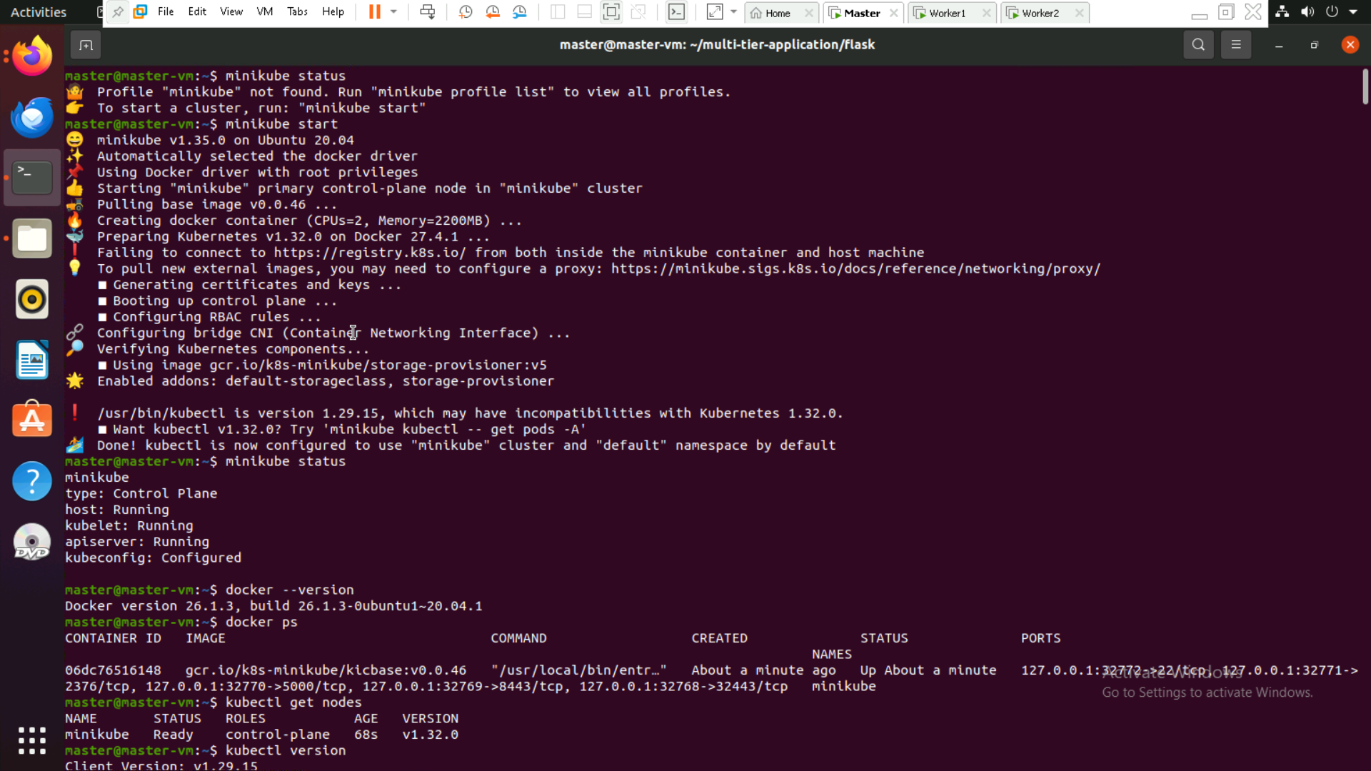

**Step 2: Check docker install and node is connected or not**

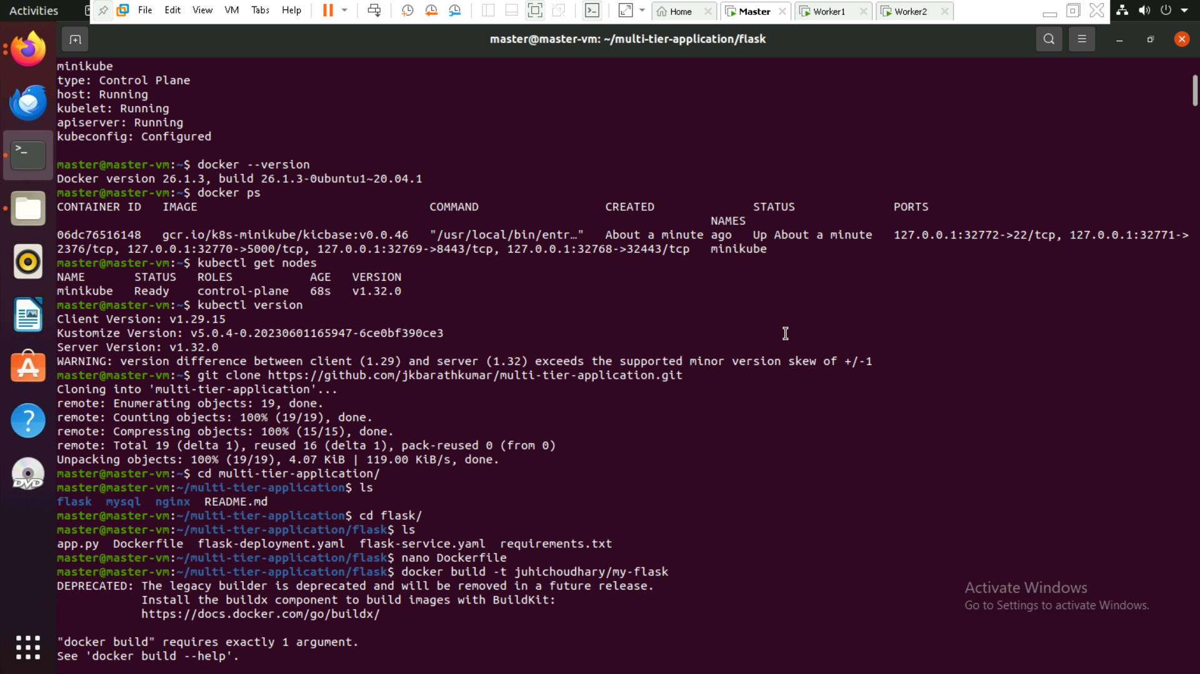

**Step 3: Make directory and add all the files with code**

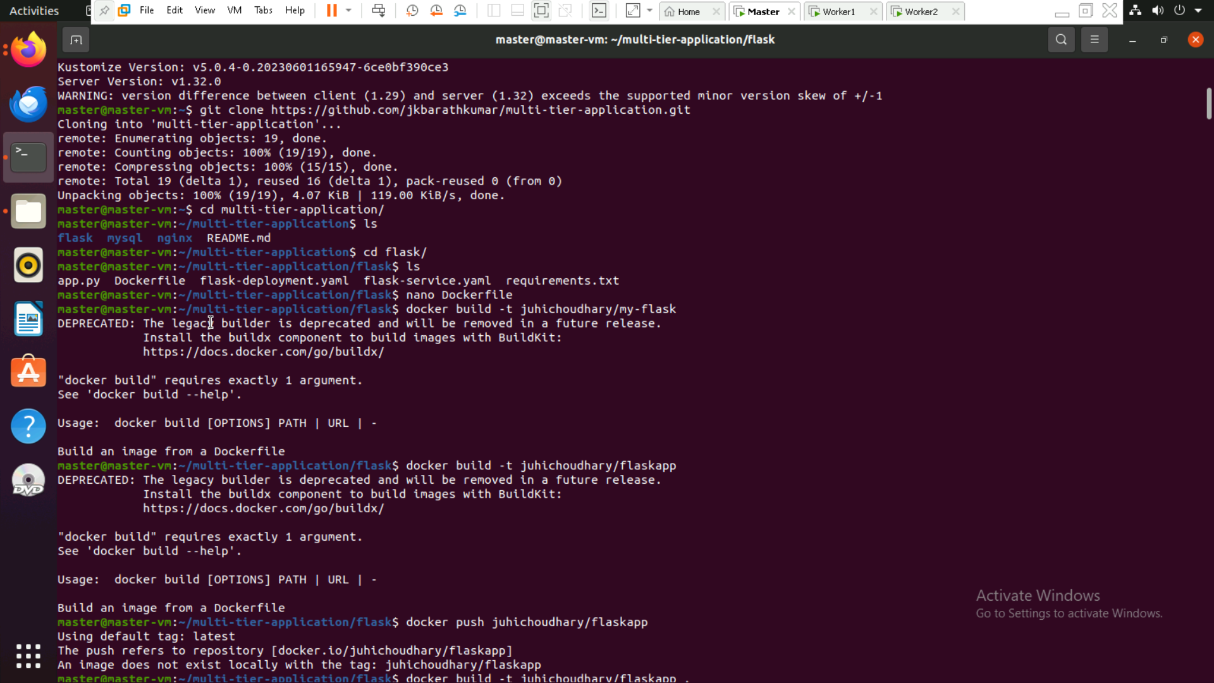

**Step 4: Build the docker image and push to the docker hub**

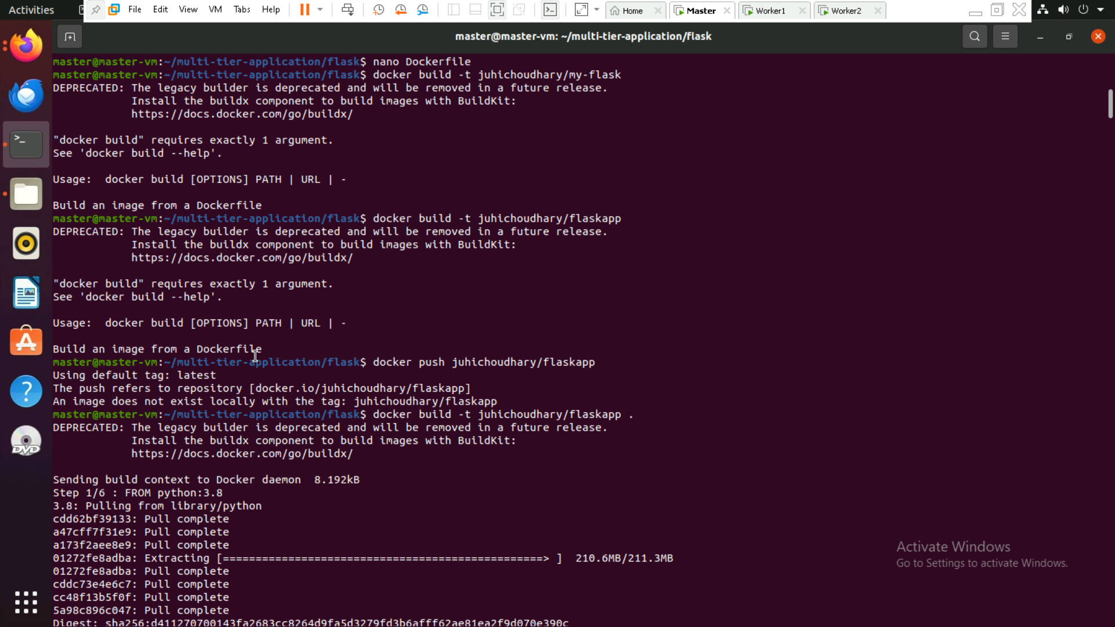

**Step 5: login to the Docker and push the image**

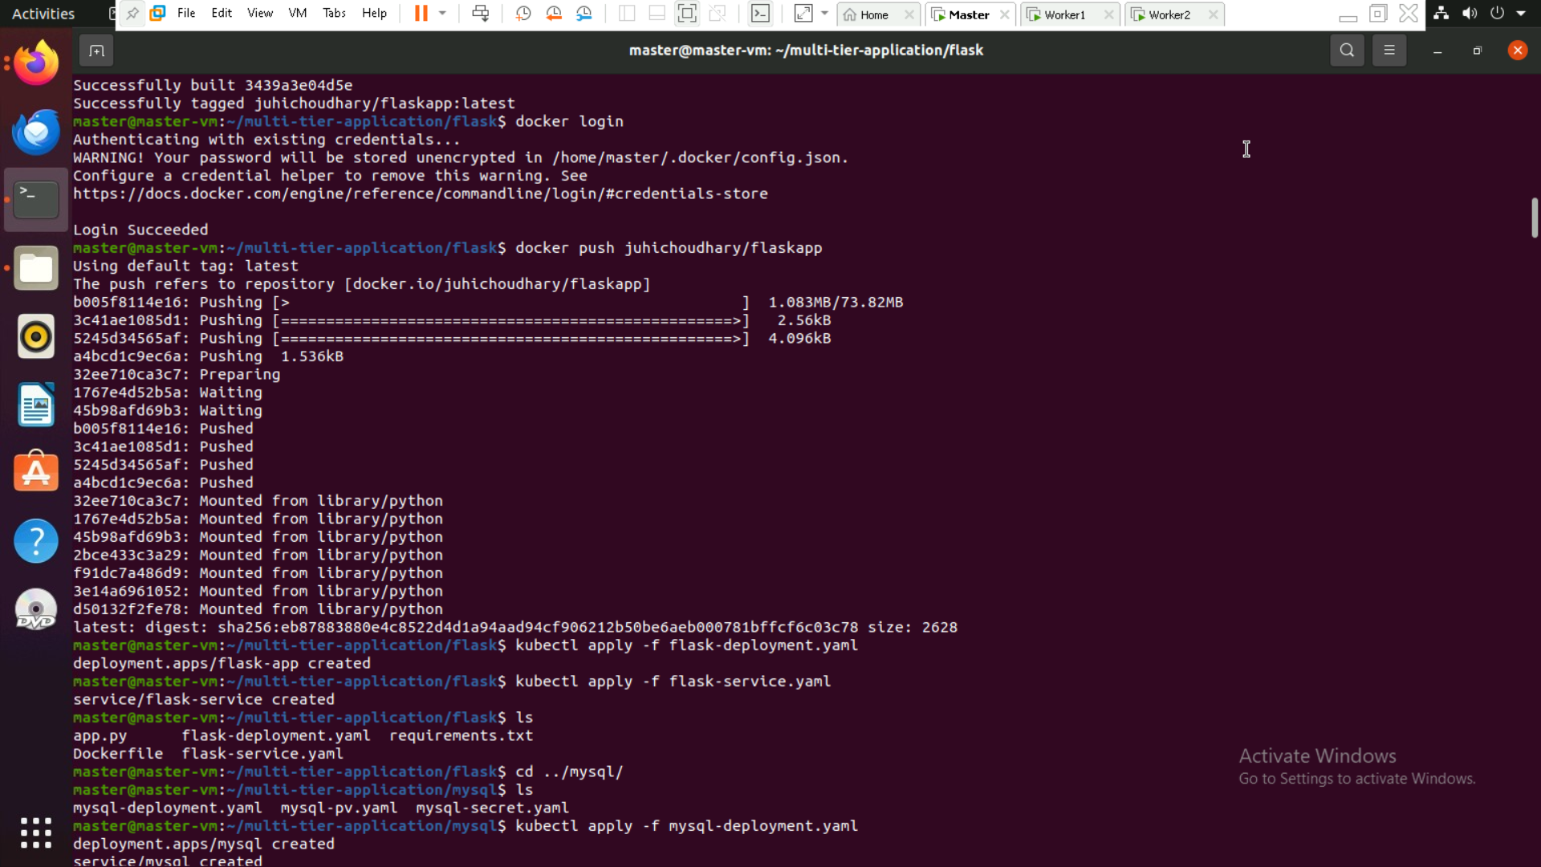

**Step 6: Apply the configuration**

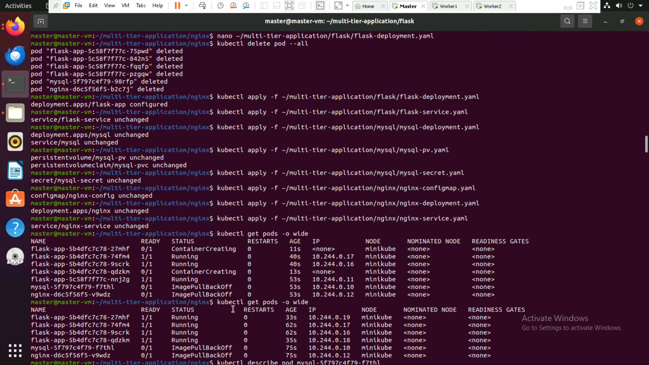

**Step 7: get all pods**

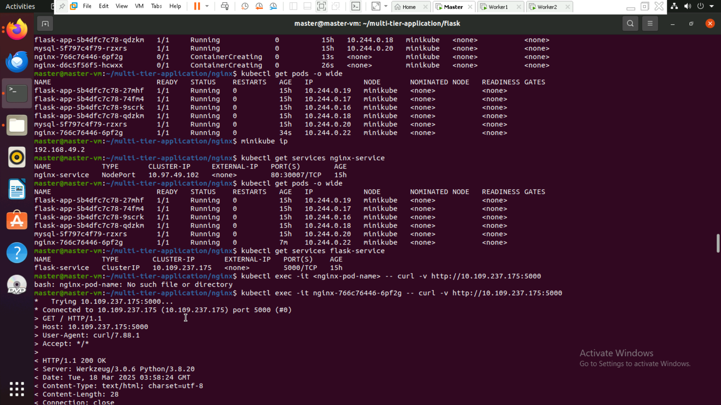

**Step 8: Database created and outputs**

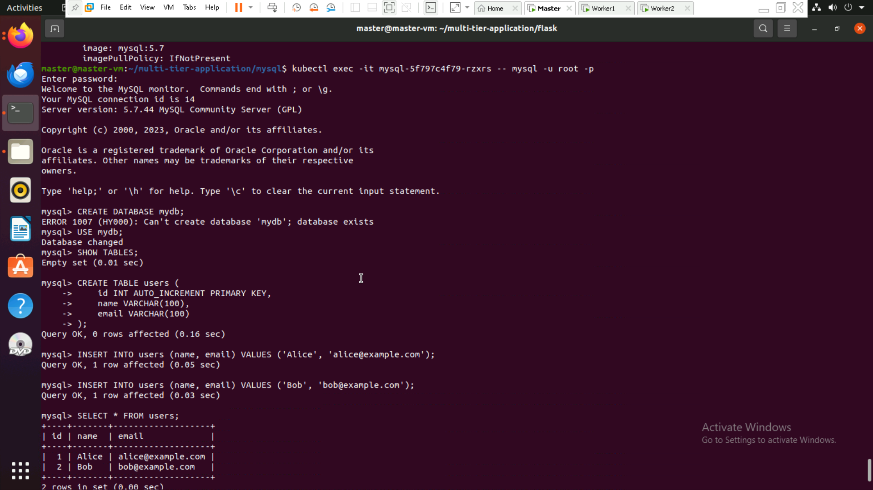

**Step 9: open browser and run ip:30007**

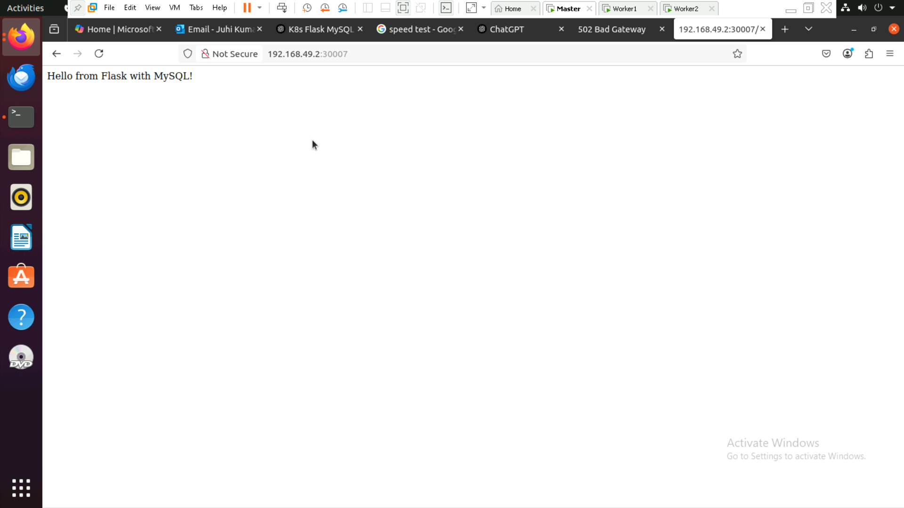

**Step10: Database output table created**

